**Application for the Direct Quota/ Deputation/ Re-employment Faculty Posts**

**(Reference: Public Notice No. AIMS/2021/2405, Dated. 07-07-2021)**

**(Last Date of Application:- 18-07-2021)**

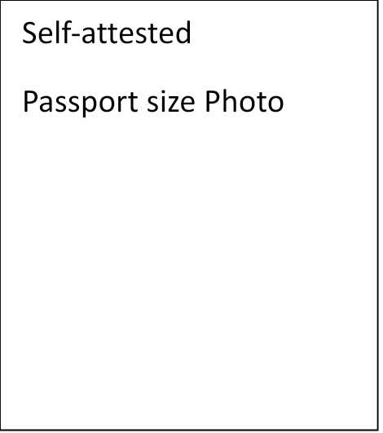**To**

**The Director Principal**

**Dr. B.R. Ambedkar State Institute of Medical Sciences**

**Sector- 56, S.A.S Nagar (Mohali)**

**AIMS, Mohali**

**Subject: Application for the post of ……………………………….**

**Department of ……………………………………………………**

**Name of the applicant …………………………………………………………………………….**

**Respected Madam,**

**I am applying for the post of Associate Professor / Assistant Professor (tick as applicable) in the department of ………………………………………………. Following required self-attested documents are attached**

|  |  |  |
| --- | --- | --- |
| **S.No** | **Name of the documents** | **Page No** |
| **1** | **Print out of the Online application received on email**  **(Click here to apply online)** |  |
| **2** | **Online Transaction No ………………. date ………………….**  **Bank Name .....................................amount..................** |  |
| **3** | **Proof of Date of Birth** |  |
| **4** | **Photo ID Proof** |  |
| **5** | **Proof of Punjabi pass at matriculation or equivalent standard** |  |
| **6** | **Caste certificate if applicable** |  |
| **7** | **MBBS (All Prof) certificates along with attempt certificate and degree** |  |
| **8** | **MD/MS certificate along with attempt certificate and degree** |  |
| **9** | **DM/MCH/DNB certificates along with attempt certificate and Degree** |  |
| **10** | **Additional qualifications** |  |
| **11** | **Registration of Degree** |  |
| **12** | **Teaching experience certificate from competent authority** |  |
| **13** | **Details of teaching experience in attached form** |  |
| **14** | **NOC from competent authority** |  |
| **15** | **If Govt Employee, proof of regular Govt Employee** |  |
| **16** | **List of Publications in prescribed format along with copy of publications** |  |

**Detail of Experience**

|  |  |  |  |  |  |  |
| --- | --- | --- | --- | --- | --- | --- |
| **Sr. No.** | **Post** | **Time Period** | | | **Institute** | **Date UG Recognition as per NMC** |
| **From** | **To** | **Total Duration** |
|  |  |  |  |  |  |  |
|  |  |  |  |  |  |  |
|  |  |  |  |  |  |  |
|  |  |  |  |  |  |  |
|  |  |  |  |  |  |  |
|  |  |  |  |  |  |  |

**This information is available on the NMC website on College and Course search under Information Desk. DNB candidates must attach proof of institution recognition from NBE**

**Research Publication**

|  |  |  |  |  |  |  |
| --- | --- | --- | --- | --- | --- | --- |
| **Sr. No.** | **Name of Research Publications** | **Type of Research Publication** | **Journal** | **Date/Year** | **Index** | **Authorship** |
|  |  |  |  |  |  |  |
|  |  |  |  |  |  |  |
|  |  |  |  |  |  |  |
|  |  |  |  |  |  |  |
|  |  |  |  |  |  |  |
|  |  |  |  |  |  |  |

**Signature of the Applicant**